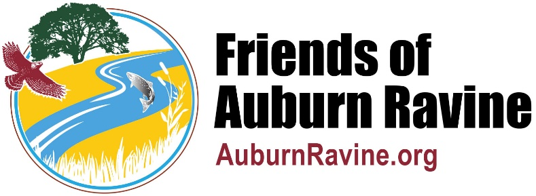
Friends of Auburn Ravine Code of Conduct
(Effective November 12, 2025)

We conduct our daily interactions with honesty and integrity. This applies to everything we do. We hold ourselves and each other to a high standard of ethical behavior. This includes respect for and kindness towards people of all nationalities, ethnicities, religions, political views, ages, genders, and abilities whether or not they are members of the extended Friends of Auburn Ravine team.
Because we adhere to this code, government agencies, water districts, news organizations, educational institutions, other non-profit organizations, and the public are able to trust what we say and do. We take personal responsibility for meeting the goals we share and keeping our commitments.
We use electronic communications responsibly. Communication, in its many forms, including social media, should be professional, appropriate, and respectful. We strive to ensure that everything we communicate is not only the whole truth as we know it, but also accurately depicts reality as best we can determine.
Conflicts of interest can undermine our judgment, threaten our reputation, and expose us to risk. We avoid conflicts of interest, disclose and resolve them promptly if they arise, and strive to avoid even the appearance of such conflicts. We do not allow our decisions to be influenced by gifts, favors, or hospitality from others.
When advocating policies or actions, we try to ensure that the policy or action is fair to all concerned, will build goodwill and better friendships, and that it will be beneficial to all concerned.
When we make a mistake, we admit it and take action to prevent its recurrence.
Credits: This Code of Conduct is based on the AT&T Code of Conduct, and the Guiding Principles of Rotary International.

